(Approx. 1190 words)

Settings – What happened to Control Panel?
Author: Phil Sorrentino, Contributing Writer, The Computer Club, Florida
www.scccomputerclub.org
Philsorr (at) yahoo.com
Way back in the days of Windows 7, the Control Panel was the way we adjusted the operation of certain parts of the Operating System. Control Panel was easily found because it was in a short list of options when you clicked the Start button. When you clicked “Control Panel,” you were presented with a set of Apps (originally called Applets), that would allow you to change the way certain features operated. (To get this list you had to choose “View by Icons” rather than “View by Categories.”) The list of Apps included, Display, Keyboard, Mouse, System, Default Programs, Power Options, Programs and features, Folder Options, Network and Sharing, Device manager, just about all the features that you can adjust. Maybe the statement at the top of the set of Apps was prophetic in its language. The Apps were introduced by a text line that said, “Adjust your computer’s settings.” And maybe the thought of Settings was carried over from the Smartphone world, (i.e. Apple’s iOS and Google’s Android) just about when Windows 10 was being developed. No matter how it evolved, Settings seems to be the preferred term for the place to go to change the way the device operates.
“Settings” has become a common feature on many computing devices. It even shows up on other things like electric ovens, exercise machines, thermostats, and kitchen appliances. So now Settings is the place to set many of the features of Windows 10. Yes, Control Panel still exists, but it is not as apparent, or easy to find. It seems like it has been moved to different places in different Windows 10 editions. But, fortunately, you can always find it just by clicking the “Type here to Search” circle next to the Start button, and then typing “Control” into the Search bar.
You may not even have to go to Control Panel for most of the things you may want to change, because clicking Settings will more than likely get you there. And, Settings is very easy to find; just click the Start button and the Settings icon, which looks like a gear, appears right above the Power icon. Click the icon and you will be shown all the Settings categories. Just to add a little confusion, these new categories are not the same categories that are used in Control Panel, although some of the titles will be familiar. The Settings screen on one of my machines is as shown here:
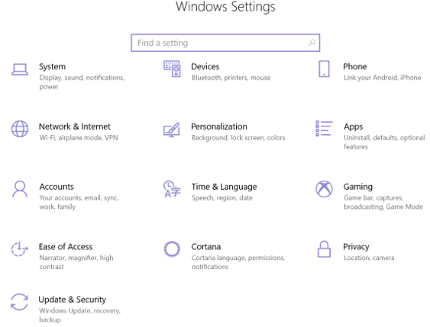
Notice that they are not is alphabetical order. Note too, that System is the first category, so Microsoft must consider these to be important settings. Here are the items in the System category:
Display. Here you will find Display-related information and settings. The first setting is “Night light,” which allows you to set a schedule for the Night Light and set the “Color temperature at night.” The introduction explains that “Screens emit blue light, which can keep you up at night.” So, by using warmer colors, there may be less interference with your sleep. (I’m only the messenger.) Here is where you can “Change the size of text, apps, and other items,” if so desired. The Resolution of the display is another setting that can be changed. (Keep in mind that if you choose a higher resolution, the text and pictures on the screen will be smaller, so if you want larger items on the screen, you will have to lower the Resolution. I know that sounds counter-intuitive.)
Sound is where you choose your output or input devices, volume, manage your sound devices and troubleshoot those devices.
Notifications & actions is where you set up the Quick Actions, the icons you see when you click the Action Center icon at the right-hand end of the taskbar. (Clicking the Action Center icon also shows you any notifications that are available.) This is also where you get to determine the notifications you can receive, and who can send you notifications.
Focus Assist is where you can choose which notification you’d like to see and hear so you can stay focused. The rest will go straight to the action center where you can see them any time.
Power & sleep. You can customize how long the screen will stay on after the last keystroke, and when the computer will go into the sleep mode. If you have a laptop, these settings are made for both “On battery power” and “When plugged in.”
Battery. Here you will see a battery charged percentage indication and if you click “Battery usage by app,” you will see how the battery is being used by various Apps. Battery saving options are also shown here.
Storage is where you can see the size of each local storage device (drive) and how much is being used. There are also a few storage related items here such as “Change how we free up space,” and “Manage Storage Spaces.” You will probably want to customize these options. You will also find “Change where new content is stored,” which determines where various file types, like documents, music, and pictures will be stored.
Tablet mode optimizes your device for a touch screen so you don’t have to use a keyboard and mouse.
Multitasking gives you control of the “Snap” feature, that is the ability to snap windows into half the overall screen. This can be useful if you want to Copy & Paste between two documents.
Projecting to this PC gives you the ability to wirelessly project some Windows and Android devices to your device. If you give presentations, turn on “This PC can be discovered for projection only when it’s plugged in.”
Shared experiences lets Apps on other devices open and message apps on your device, and vice versa. This feature improves the ability to share documents and apps among all of your devices and may or may not be useful to you.
Clipboard. You can save multiple items to the clipboard to use later as well as sync them across devices, pin frequently used items, and clear the clipboard data.
Remote Desktop lets you connect and control your PC from a remote device by using a remote desktop client. Note: You never want to enable this unless you completely trust the person who wants to take over control of your PC. You might do this if someone you know and trust is trying to help you with something and they are at a remote location.
About contains a lot of device specification information. This is where you will find hardware information such as Device name (with the ability to change the name), Processor type, Amount of memory, and the system type, 64bit or 32 bit. Here you will also find Software information such as the Windows 10 edition, like Windows Home or Pro, and the version number.
“Settings” is a very important and comprehensive part of Windows 10. In this article, we have only reviewed the first category, System; there are 12 more categories full of various types of settings. Stay tuned.

